UNIT III ENERGY SOURCES 9

Conventional and Non Conventional Energy Sources – Conventional: Fossil Fuels - classification of fuels - coal - analysis of coal (proximate and ultimate) - carbonization - manufacture of metallurgical coke (Otto Hoffmann method) - petroleum - manufacture of synthetic petrol (Bergius process) - natural gas - compressed natural gas (CNG) - liquefied petroleum gases (LPG). Non Conventional: Solar energy – Solar Energy Conversion – Solar Cells, Wind Energy, Nuclear Energy – Nuclear fission and fusion – Nuclear chain reactions - Nuclear reactor – Nuclear Power Plant – Breeder Reactor.

ENERGY SOURCES
Intruduction
“Fuel is a substance, containing carbon as a main constituent, which on burning gives large amount of heat, which can be used economically for domestic and industrial purposes”.
Ex: Wood, coal, kerosene, petrol, diesel, natural gas, producer gas, oil gas etc.
During the combustion process the reactants produce products like CO₂, H₂O etc. of lower energy. The energy released during the combustion process is the difference in the energy of the reactants and the products.
Fuel + O₂ Products + Heat
(More energy) (Less Energy)

Classification of fuels
Based on Occurrence - 2 Types.
- Primary Fuels – It occurs in nature such as. Ex: Coal, Crude oil, Natural Gas.
- Secondary Fuels – It is derived from primary fuels. Ex: Coke, Petrol, Coal gas.
Based on physical state – 3 types
- Solid fuels, eg., coal, coke,
- Liquid fuels eg., gasoline, diesel.
- Gaseous fuels eg., coal gas, natural gas.

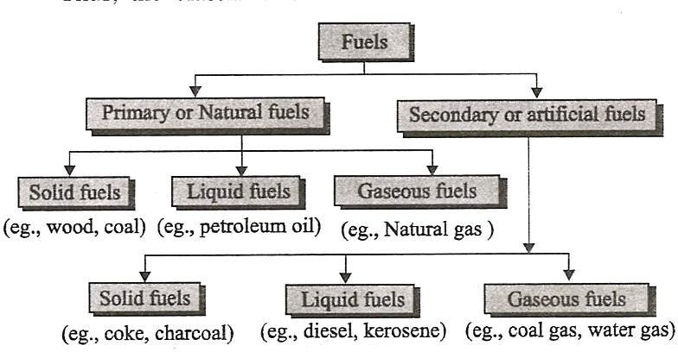
SOLID FUEL
Advantages of solid fuels:
- Solid fuels are easily available and they are cheap.
- Handling and transportation are easy.
- They can be stored conveniently without any risk.
- They have a moderate ignition temperature.
Disadvantages of solid fuels:
- Combustion process cannot be easily controlled.
- The calorific value is comparatively lower.
- They form large amount of ash and its disposal is a big problem.
- A large space is required for storage.
COAL
Coal: - Coal is a fossil fuel which occurs in layers in the earths crust. It is formed by the partial decay of plant materials accumulated millions of years of ago and further altered by action of heat and pressure. The process of conversion of wood into coal can be represented as
Wood Peat LigniteBituminous Coal Anthracite
1) Peat:- Peat is brown-fibrous jelly like mass.
2) Lignite:- these are soft, brown coloured, lowest rank coals 91
3) Bituminous coals:- These are pitch black to dark grey coal
4) Anthracite:- It is a class of highest rank coal

Analysis of coal
Two types of Analysis
- Proximate Analysis
- Ultimate Analysis
Proximate Analysis:
It involves the determination of percentage of following in coal
a. Moisture content
b. Volatile matter
c. Ash content
d. Fixed carbon
(a) Moisture content
1gm of powdered and air-dried coal sample in crucible is heated at 100-150⁰C in an electric air oven for 1 hour.
The loss in weight of the sample is found out and percentage of moisture is calculated as
% of moisture = (Loss in weight of coal / Weight of air-dried coal) ×100
(b) Volatile matter
In this the crucible with residual coal sample is covered with a lid and heated at 950± 20⁰C for 7mins in a muffle furnace. The loss in weight is found out.
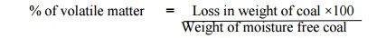
(c) Ash Content
The crucible with residual coal sample is heated without lid at 700 ± 50 ⁰C for ½hour in a muffle furnace. The loss in weight is found out.
(d) Fixed Carbon
of fixed carbon = percentage of (a+b+c)
Significance of proximate analysis:
High percentage of moisture content is undesirable because
High percentage of volatile matter is undesirable because
High percentage of ash content is undesirable because
High percentage of fixed carbon content is desirable because

Ultimate analysis:
Itinvolves the determination of % of Carbon, Hydrogen, Nitrogen, Sulphur&Oxygen in coal.
- Carbon & Hydrogen: A known amount of coal sample is burnt with O₂ in a combustion apparatus. In coal carbon & hydrogen are converted into CO₂& H₂O & those are absorbed by KOH tubes & CaCl₂ tubes.
X 100
44
Weight of coal sample taken
% of Carbon in coal = Increase weight in KOHtubes X 12
C + O₂ CO₂
12 44

2KOH + CO₂ → K₂CO₃ + H₂O
X 100
18
X 2
Weight of coal sample taken
% of Hydrogen in coal = Increase weight inCaCl2tubes
H₂ + ½ O₂ H₂O₂
218

CaCl₂ + 7H₂O → CaCl₂ . 7H₂O
- Nitrogen: It is carried out by Kjeldahl’smethod.A known amount of coal is heated with Con. H₂SO₄ in presence of K₂ SO₄ catalyst in a long necked flask called Kjeldahl’s flask. Nitrogen is converted into ammonium sulphate. Then it is heated with NaOH& absorbed by HCl.
2N + 3H₂ + H₂SO₄ → (NH₄)₂SO₄
(NH₄)₂SO₄+ 2NaOH → 2NH₃ + Na₂SO₄ + 2H₂O
NH₃ +HCl → NH₄Cl
Weight of coal sample
% of Nitrogen in coal = 1.4 X volume of acid consumed X Normality.
- Sulphur:A known amount of coal is completely burnt in a bomb calorimeter. Here sulphur is converted into sulphate& treated with BaCl₂, BaSO₄ is obtained.

X 100
32
233
X
Weight of coal sample
% of Sulphur in coal = weight of BaSO4obtained

- Ash: The residual coal taken in the crucible and then heated without lid in a muffle furnace at 700 + 500c for ½ hour. The crucible is then taken out, cooled first in air, then in desiccators and weighed. Hearing, cooling and weighing are repeated, till a constant weight is obtained. The residue is reported as ash on percentage-basis.
Thus,
Percentage of ash = Weight of ash left X 100
Weight of coal taken

- Oxygen: The % of oxygen is calculated as follows,
% of Oxygen in Coal = 100 - % of ( C + H+N+S+ash)
Importance or significance of Ultimate analysis:

- Higher % of carbon & hydrogen, better is the quality of coal & higher its calorific value.

- Should have very little nitrogen content.

- Presence of sulphur is undesirable because it forms harmful gases during the combustion.

- Lower of the Oxygen increases the higher its calorific value.

CARBONISATION OFMETALLURGICAL COKE
When coal is heated strongly in the absence of air, it is converted into lustrous, dense, porous and coherent mass known as coke. This process of converting coal is known as carbonization.
METALLURGICAL COKE
When bituminous coal is heated strongly in the absence of air, the volatile matter escapes out and the mass becomes hard, porous and coherent which is called Metallurgical coke.
PREPARATION
Otto-Hoffman’s method
When bituminous coal is heated strongly in the absence of air, the volatile matter escapes out & the mass becomes hard, strong, porous, which is called metallurgical coke.
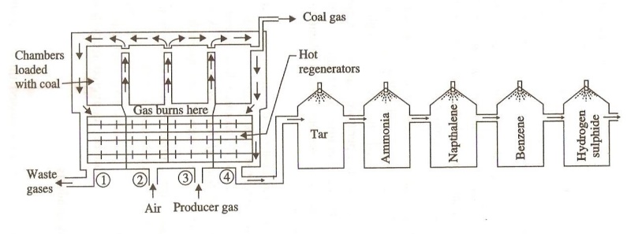
In order to (i) Increase the thermal efficiency of the carbonization process &
- Recover the valuable by products by this method.
  - This oven consists of a number of silica chambers.
  - Each chamber is about 10-12 m long, 3-4 m height & 0.4 – 0.45m wide.
  - Coal is introduced into the silica chambers & heated 1200°C by air & producer gas.
  - I & IV regenerators are heated by hot flue gases & II & III regenerators are heated by incoming air &producergas.
  - When the process is complete, the coke is removed & cool by with water.
  - Time taken for this process is 12-20 hours.
  - The yield of the coke is about 70%
  - From out coming flue gas, it gives valuable products like Tar, ammonia, benzene. H₂S are obtained.
Recovery of by products:
- Tar: the flue gases are first passed through a tower, in which liq. NH₃ is sprayed, tar is collected at the bottom of the tank.
- Ammonia: The gases are then passed through 2nd tower, in which water is sprayed & NH₃ gets in the form of NH₄OH.
- Naphthalene: The gases are again passed through next tower, cooled water is sprayed, Naphthalene gets & condensed.
- Benzene: The gases are passed through next tower, petroleum oil is sprayed, benzene gets condensed.
- H₂S gas: The remaining gases are then passed through a purifier, H₂S gas is obtained. The final gas left out is called coal gas.
Advantages:
(i) Valuable by product like NH₃ benzene etc, are obtained.
(ii) The carbonization time is less.(iii) Heating is done by extremely by producer gas.
PRIMARY LIQUID FUELS – PETROLEUM / CRUDE OIL
Crude oil is a mixture of paraffinic, olefinic and aromatic hydrocarbons with small amounts of
organic compounds like N, O and S. The approximate composition of petroleum is:

Constituents Percentage (%)
C 80-87
S 0.1-3.5
N and O 0.1-0.5
H 11-15
Petroleum may be of three types:
1. Paraffinic based – straight chain hydrocarbons
2. Naphthenic based – Cycloparaffins and aromatic
3. Mixed based – both paraffinic and naphthenic

MANUFACTURE OF SYNTHETIC PETROL
The gasoline, obtained from the fractional distillation of crude petroleum oil, is called straight run petrol. As the use of gasoline is increased, the amount of straight run gasoline is not enough to meet the requirement of the present community. Hence, we are in need of finding out a method of synthesizing petrol.
Hydrogenation of coal (or) Synthetic petrol
Coal contains about 4.5% hydrogen compared to about 18% in petroleum. So coal is a hydrogen deficient compound. If coal is heated with hydrogen to high temperature under high pressure, it is converted to gasoline. The preparation of liquid fuels from solid coal is called Hydrogenation of coal (or) synthetic petrol.
There are two methods available for the hydrogenation of coal
1. Bergius process (or direct method).
2. Fischer-Tropsch process (or indirect method).
Bergius process (or) direct method
- In this process, the finely powdered coal is made into a paste with heavy oil and a catalyst powder (tin or nickel oleate) is mixed with it.
- The paste is pumped along with hydrogen gas into the converter, where the paste is heated to 400 − 450°C under a pressure of 200 − 250 atm.
- During this process hydrogen combines with coal to form saturated higher hydrocarbons, which undergo further decomposition at higher temperature to yield mixture of lower hydrocarbons.
- The mixture is led to a condenser, where the crude oil is obtained.
- The crude oil is then fractionated to yield (i) Gasoline (ii) Middle oil (iii) Heavy oil.
- The middle oil is further hydrogenated in vapour phase to yield more gasoline. The heavy oil is recycled for making paste with fresh coal dust.
- The yield of gasoline is about 60% of the coal used.

Gaseous Fuels
The gaseous fuels are most preferred because of their ease of storage, transport, handling and ignition. These are classified into two types.
a) Primary fuels Ex:- Natural gas
b) Secondary fuels ex: - Coal gas, producer gas, water gas.
Natural Gas
The natural gas is obtained from the wells dug in the earth during mining of petroleum. It is mainly composed of methane and small quantities of ethane along with other hydrocarbons.
If the lower hydrocarbons are present, the gas is called dry gas or lean gas but if the hydrocarbons having the higher molecules are present, the gas is known as rich or wet gas.
The average composition of natural gas is as follows.
Methane – 88.5%, Ethane – 5.5%, Propane – 3.7% Butane– 1.8%,
Pentane, hydrogen and higher hydrocarbons – 0.5%
The calorific value of natural gas varies from 8000-14000 K.cal/m3.
Applications
- It is an excellent domestic fuel and industrial fuel.
- It is also used as raw material for the manufacture of carbon-black, methanol, formaldehyde etc.
- Methane on microbiological fermentation gives synthetic proteins which are used as animal feed.

COMPRESSED NATURAL GAS (CNG)
When the natural gas is compressed, it is called Compressed Natural Gas (CNG). The primary component present in CNG is methane. It is mainly derived from natural gas. The natural gas can either be stored in a tank of a vehicle as compressed natural gas (CNG) at 3,000 or 3,600 psi or as liquified natural gas (LNG) at typically 20-150 psi. The average composition of CNG is as follows
Constituents Percentage (%)
Methane 88.5
Ethane 5.5
Propane 3.7
Butane 1.8
Pentane 0.5
Properties
1. CNG is the cheapest, cleanest and least environmentally impacting alternative fuel.
2. Vehicles powered by CNG produce less carbon monoxide and hydrocarbon (HC) emission.
3. It is less expensive than petrol and diesel.
4. The ignition temperature of CNG is about 550°C.
5. CNG requires more air for ignition.
Uses :
CNG is used to run an automobile vehicle just like LPG.
Advantages of CNG over LPG
1. CNG produces less pollutants than LPG.
2. CNG is cheaper and cleaner than LPG.
3. The octane rating of CNG is high; hence the thermal efficiency is more.
4. It does not evolve sulphur and nitrogen gases.
5. It mixes very easily with air than the other gaseous fuels.
6. Noise level is much less than diesel
7. CNG vehicle limit 40% less of nitrogen oxide, 90% less of hydrocarbons, 25% less of CO2
LIQUEFIED PETROLEUM GAS (LPG)
It is obtained as a by-product during fractional distillation of crude petroleum oil or by cracking of heavy oil. It consists of propane and butane. It can be readily liquefied under pressure, so it can be economically stored and transported in cylinders. The average composition of LPG is as follows
Constituents Percentage (%)
n-Butane 38.5
Isobutane 37
Propane 24.5
Calorific value 25,000kcal/m³
Advantages gaseous fuels of LPG over
- LPG consists of hydrocarbons, so it burns cleanly without leaving any residue.
- The LPG (hydrocarbons) has higher calorific value than the other gaseous fuels containing H₂ or CO. The calorific value is 7 times higher than coal gas and 3 times higher than natural gas.
- LPG is characterized by high thermal efficiency and heating rate.
- It is easy to manipulate.
- Comparatively it is less of health hazard, even in case of leakage.
- It is free from CO, so it is less hazardous.
Disadvantages of LPG over other gaseous fuels.
- Due to its faint odour, leakage cannot be easily detected.
- Its octane value is low.
- Handling must be done under high pressure.
- LPG is suitable only for the engines working under high compression ratio.
Characteristics of LPG
- It has high calorific value (27,800 kcal/m3)
- It gives less CO and least unburnt hydrocarbons. So it causes least pollution.
- It gives moderate heat which is very good for cooking
- Its storage is simple. It is colourless
- It has tendency to mix with air easily
- Its burning gives no toxic gases though it is highly toxic
- It neither gives smoke nor ash content
- It is cheaper than gasoline and used as fuel in auto vehicles also
- It is dangerous when leakage is there
Applications
In Food industry: LPG is widely used in the food industry like hotels, restaurants, bakeries, Canteens etc. Low sulphur content and controllable temperature makes LPG the mostPreferred fuel in the food industry.
SOLAR ENERGY
Solar energy conversion:
It is the process of conversion of direct sunlight into more useful forms. It occurs by the following two mechanisms.
    - Thermal conversion
    - Photo conversion
Thermal conversion
- It involves absorption of thermal energy in the form of IR radiation.
- Solar energy is an important source for low temperature heat which is useful for heating buildings, water and refrigeration.
Methods of thermal conversion
  - Solar heat collectors
  - Solar water heater
Solar heat collectors
Solar heat collectors consists of natural materials like stones, bricks or materials like glass, which can adsorb heat during the day time and release it slowly at night.
Uses:
It is generally used in cold places, which houses are kept in hot condition using solar heat collectors.

Solar water heater
It consists of an insulated box inside of which is painted with black paint. It is also provided with a glass lid to receive and store solar heat. The black painted copper coil allows the cold water in and heats it up and flows out into a storage tank.
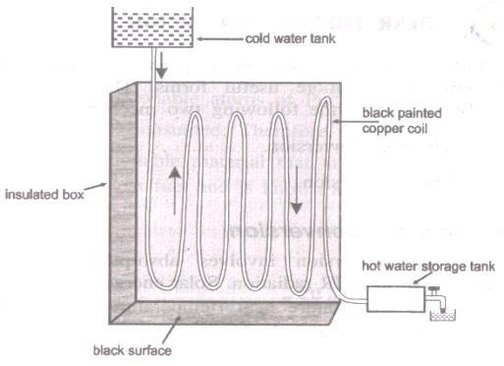
Solar water heater

Photo conversion
It involves conversion of light energy directly in to electrical energy.
Example: Photo galvanic cell or solar cell
Photo galvanic cell or solar cell
It is the one which converts the solar energy directly into electrical energy.
Principle:
- The basic principle is based on the photovoltaic effect.
- When solar rays fall on a two layer of semiconductor devices, a potential difference between two layers is produced.
- This potential difference causes flow of electrons and produces electricity.
Construction
Solar cell consists of a p-type semiconductor (Si doped with B) and n- type semiconductor (Si doped with P). They are in close contact with each
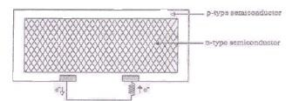

Working
- When solar rays fall on n-type semiconductor
- The electrons from the valence band get promoted to the conduction band and cross p-n junction into p type semiconductor.
- Thereby potential difference is produced which causes flow of electrons and hence current is generated.
- Thus when this p and n layers are connected to an external circuit, electrons flow from n- layer to p-layer and hence current is generated.
Applications of solar cells
  - Lighting purpose:
Solar cells can be used for lighting purpose. Nowadays electrical street lights are replaced by solar street lights.
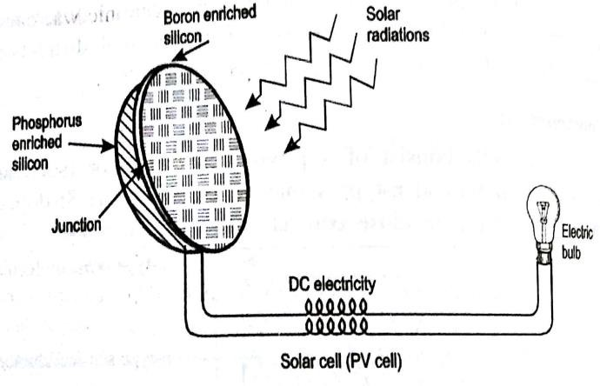
  - Solar pumps can be run by solar battery.
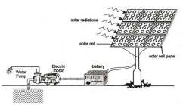
When a large number of solar cells are connected series it form a solar battery. Solar battery produces more electricity which is enough to run, water pump, street-light etc. They are also used in remote areas where conventional electricity supply is a problem.

  - Used in calculators, electronic watches, radios and TV.
  - Used to drive vehicles.
  - Used in space craft and satellites.
Advantages
- Solar cells can be used in remote areas and hilly regions.
- Maintenance cost is low.
- Solar cells are non-polluting and eco-friendly.
- Their life time is long.
- They need not be charged.
Disadvantages
- Capital cost is high.
- Storage of solar energy is not possible.
- It produces only DC current.
- Solar energy is not available in night time.
Wind energy
- Moving air is called wind.
- Energy recovered from the force of the wind is called wind energy.
- The wind energy is harnessed by making use of wind mills.
Methods of harnessing wind energy
Wind mills
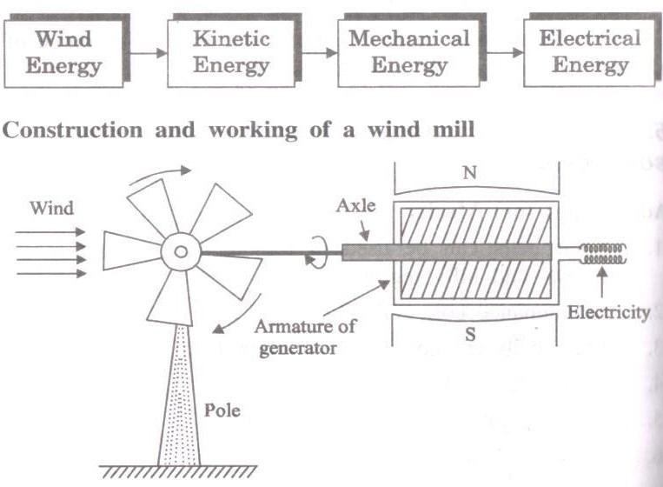
- The strike of blowing wind on the blades of the wind mill makes it rotating continuously.
- The rotational motion of the blade drives a number of machines like water pump, flour mills and electric generators.

- Nowadays windmill uses large sized propeller blades and connected to a generator through a shaft.
- Wind mills are capable of generating about100 kW electricity.
Wind farms
When a large number of wind mills are installed and joined together in a definite pattern it forms a wind farm. The wind farm produces a large amount of electricity.
Condition
The minimum speed required for satisfactory working of a wind generator is 15Km/hr.
Advantages
- It does not cause any pollution.
- It is very cheap.
- It is renewable.
Disadvantages
- Public resists for locating the wind forms in populated areas due to noise generated by the machines.
- Wind forms located on the migratory routes of birds will cause hazards.
- Wind mill interferes with electromagnetic signals.

Nuclear Energy
Nuclear Energy
The enormous energy thus released during the Nuclear Fission & Fusion reaction is known as Nuclear Energy.
Nuclear fission:
Nuclear fission is defined as the process of splitting of heavier nucleus into two or more smaller nuclei with simultaneous liberation of large amount of energy.
Example:
₉₂U²³⁵+ ₀n¹ → [₉₂U²³⁶] → ₃₆Kr⁹² + ₅₆Ba¹⁴¹ + 3 ₀n¹+ 200.5 MeV (Energy)
Mechanism of nuclear ﬁssion
- When U²³⁵ is bombarded by thermal neutron (slow moving), unstable U²³⁶ is formed.
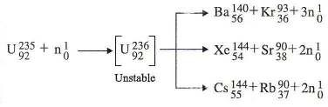
- The unstable U²³⁶ then divides into two approximately equal nuclei with the release of neutrons and large number of energy
Illustration
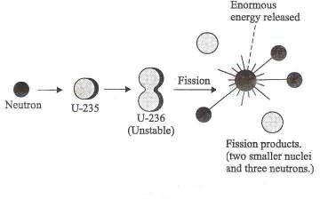
During the nuclear ﬁssion a large amount of energy is released.
Characteristics of nuclear fission reaction:
- Heavy nucleus splits into two or more nuclei.
- Two or more neutrons are produced by fission of each nucleus.
- Large quantity of energy is produced during the nuclear fission reaction.
- All the fission fragments are radioactive.
- Beta and gamma radiations are produced.
- The atomic weights of nuclear fission product ranges from 70 to 160.
- All the fission reactions are self-propagating chain reaction because one of the fission products is neutron.
- The nuclear reactions can be controlled by absorbing the neutrons using Cd, Boron.
- The neutrons produced during fission process make it a chain reaction.
- The number of neutrons resulting from a single fission is known as multiplication factor. When it is less than 1, nuclear chain reaction does not take place.
- Atom bomb is based on this reaction.

Nuclear fusion
Nuclear Fusion is defined as the process of combination of lighter nuclei into heavier nucleus with simultaneous liberation of large amount of energy. (e.g) solar system.
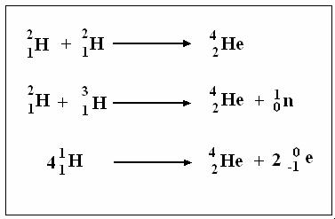

Characteristics of nuclear fusion:
  - Nuclear fusion reaction occurs in sun(very high temperature).
  - The mass number and the atomic number of the products are higher than that of the starting elements.
  - This process does not emit any kind of radio active rays.
  - This process does not give rise to chain- reaction.
  - It cannot be performed under controlled manner.
  - Hydrogen bomb is based on this reaction.
Differences between nuclear fission and nuclear fusion
S.No | Nuclear fission | Nuclear fusion
1 | It is the breaking of heavier nucleus | It is the combination of lighter nuclei
2 | It emits radioactive rays | I t does not emit radioactive rays
3 | It occurs at ordinary temperature | It takes place at very high temperature (>10⁶K)
4 | The mass number and atomic number of the fission product is less than the starting elements | The mass number and atomic number of the fusion product is higher than the starting elements.
5 | It give rise to chain reaction | It does not give rise to chain reaction
6 | Neutrons are emitted | Positrons are emitted
7 | It can be controlled | It cannot be controlled

Nuclear Chain Reaction
It is a fission reaction, where the neutrons from the previous step continue to propagate and repeat the reaction is called nuclear chain reaction.
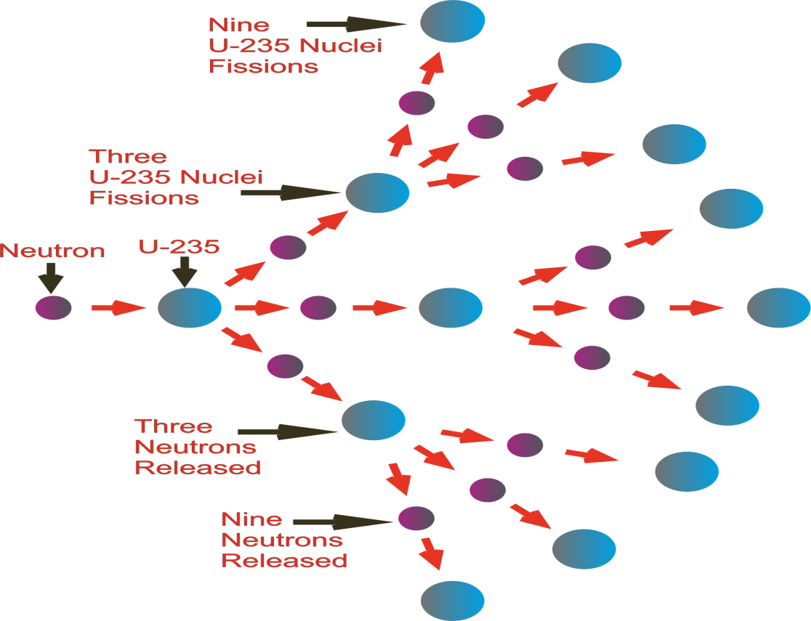

Reaction path
- U235 nucleus is hit by a neutron, followed by the release of three neutrons along with product nuclei.
- Each of the three neutrons produced in the reaction may hit another U235 nucleus, causing nine subsequent reactions.
- These nine reactions in turn, give rise to 27 reactions.
- This process of propagation of the reaction by multiplication of neutrons is referred to as a chain reaction.
Reason for less energy
- Some neutrons, released in the fission of U235 may escape into the air and some absorbed by U238 present as impurity.
- This will result in breaking of the chain and the amount of energy released will be less than expected.
- So, the amount of energy released will be less than expected.

How to improve the amount of energy?
For a nuclear chain reaction to continue, sufficient amount of U²³⁵ must be present to capture the neutrons.
Critical mass
The minimum amount of fissionable material requited to continue the nuclear chain reaction is called critical mass.
The critical mass of U-235 is between 1 to 100 Kg.
  - Super critical mass
It is the mass of the fissionable material which is more than the critical mass.
  - Sub critical mass
It is the mass of the fissionable material which is smaller than the critical mass.
Nuclear Energy
The energy released by the nuclear reaction is called nuclear energy.
Cause of the release of energy
The sum of the masses of the products is slightly less than the sum of the masses of the reactants.
The loss in mass gets converted into energy according to the Einstein equation, E= mc2
Where m- loss in mass, c- velocity, E- energy
Hazards of using nuclear energy
- The nuclear radiation can damage the structure of cells in the human body.
- It causes diseases like cancer and blindness.
- It causes genetic disorder in a human body.
- It causes sterility in young generation.
Types of nuclear fission reaction
- Uncontrolled nuclear fission reaction:
If a nuclear fission reaction is made to occur in an uncontrolled manner, then the energy released can be used for many destructive purposes. Example- Atom bomb
- Controlled nuclear fission reaction:
If a nuclear fission reaction is made to occur in a controlled manner, then the energy released can be used for many constructive purposes. Example-Nuclear power plant.

LIGHT WATER NUCLEAR POWER PLANT
The arrangement or equipment used to carry out fission reaction under controlled conditions is called nuclear reactor.
The energy released by the fission reaction in the nuclear reactor can be used to produce steam which can turn turbines and produce electricity.
COMPONENTS OF A NUCLEAR REACTOR
- Fuel rods
- Control rods
- Moderators
- Coolant
- Pressure Vessel
- Protective shield
- Heat exchanger
- Turbine
Fuel rods:
The fissionable material used in the nuclear reactor is enriched U-235. It is used in the form of rods or strips.
Example: U235, Pu239
Function:
It produces heat and neutrons. This neutron starts nuclear chain reaction.
Control rods
To control the rate of fission of U-235, movable rods made of cadmium (Cd) or boron (B) are suspended between fuel rods. These rods absorb the excess neutrons. So the fission reaction proceeds at steady rate. These rods are lowered and raised as of need.
If the rods are deeply inserted inside the reactor, they will absorb more neutrons and the reaction becomes very slow. If the rods are pushed outwards, they will absorb less neutrons and the reaction will be very fast.
Example: Cadmium, Boron
₄₃Cd¹¹³+ ₀n¹₄₃Cd¹¹⁴ + γ ray
₅B¹⁰+ ₀n¹ ₅B¹¹ + γ ray
Function: It controls the nuclear chain reaction and avoids the damage to the reactor.
Moderators
The substances used to slow down the neutrons are called moderators.
Example: Ordinary water, Heavy water, graphite, beryllium.
Function: The kinetic energy of fast neutron (1meV) is reduced to slow
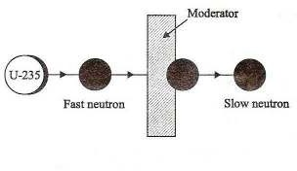
Coolant
In order to absorb the heat produced during fission reaction, the coolant is circulated in the reactor core. It enters the base and leaves at the top. The heat carried by outgoing liquid is used to produce steam.
Example: Water (act as coolant and moderator), Heavy water, liquid metal (Na or K)
Function: It cools the fuel core.
Pressure vessel
It encloses the core and also provides the entrance and exit passages for coolant.
Function: It withstands the pressure as high as 200 atm.
Protective shield
The moderator, control rods and fuel element are enclosed in a chamber which has a thick concrete shield (10m thick).
Function: The environment and the operating persons are protected from destruction in case of leakage of radiation.
Heat exchanger
It transfers the heat liberated from the reactor core to boil water and produce steam at about 400Kg/cm2.
Turbine
The steam generated in the heat exchanger is used to operate a steam turbine, which drives a generator to produce electricity.
Working of light water nuclear reactor:
It is the one in which U-235 fuel rods are submerged in water. Here water acts as coolant and moderator.
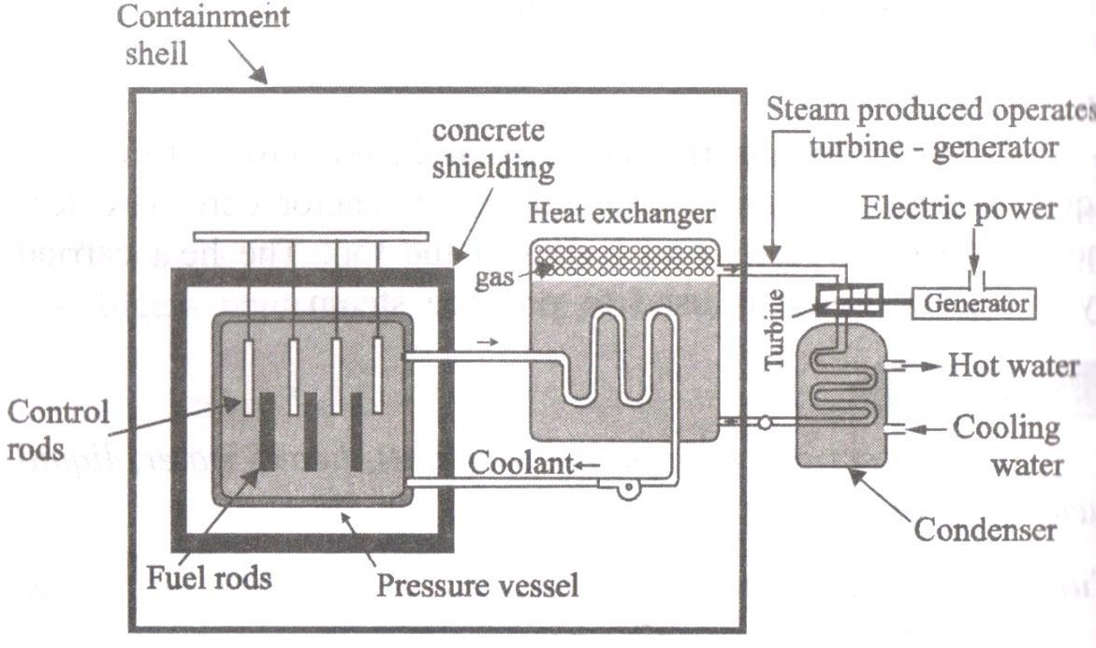
The fission reaction is controlled by inserting or removing control rods of B10 automatically from the space in between the fuel rods. The heat emitted is absorbed by the coolant (light water).
The heated coolant then goes to the heat exchanger containing sea water, which is converted to steam. The steam drives the turbines, generating electricity.
Breeder reactor
Breeder reactor is the one which converts non-fissionable material (U238, Th232) into fissionable material (U235, Pu239). Thus the reactor produces or breeds more fissionable material than it consumes.
Illustration:
U ²³⁸+ ₀ n¹Pu²³⁹+ 2e⁻
92 94
Non- Fissionable Fissionable
₉₄Pu ²³⁹+ ₀ n¹ Fission Product + 3 ₀ n¹

In breeder reactor, three neutrons are emitted during the fission of U235. Among the three neutrons, only one neutron is used for propagation step. The other two neutrons are allowed to react with U238. Thus two fissionable atoms of Pu239 are produced from one fissionable U235. Therefore breeder reactor produces more fissionable material than it uses. Pu239 is known as secondary fuel or man-made fuel.
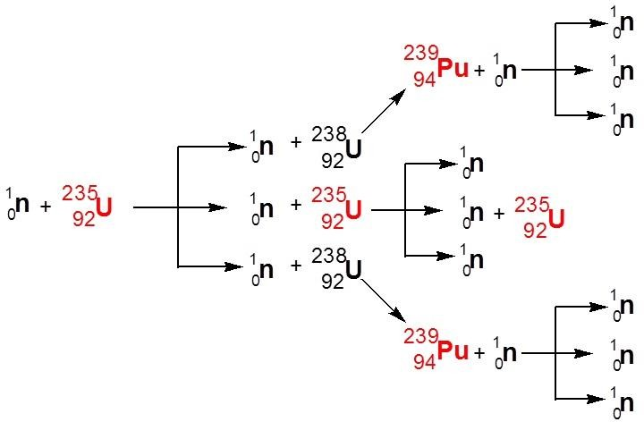
Significance:
- The non-fissionable materials such as U238 and Th232 are called as fertile materials.
- The fissionable materials such as U235 and Pu239 are called as fissile materials.
- Efficiency of breeder reactor is more since regeneration of fissile materials takes place.

